An introduction to  
Reproduce the results in the manuscript

Zhanglin Li

[lizhl@cug.edu.cn](mailto:lizhl@cug.edu.cn)

Outline

An introduction to reproduce the results in the manuscript 1

1. Prerequisite 2

2. Operation steps 2

3. Parameter configurations 8

4. A video demonstration 9

5. Notes 10

## Prerequisite

1. An x64 Microsoft Windows OS is required for the current program.
2. An X64 python which can be found in [https://www.python.org/downloads/] or [KrigLavByGA\Compiled_exe_programs\prerequisite\python-2.7.14.amd64.msi] is also needed.
3. The data and source code applied in this manuscript can be obtained by visiting: <https://github.com/lizhanglin/GK_V1>. Please see **Figure 1**.

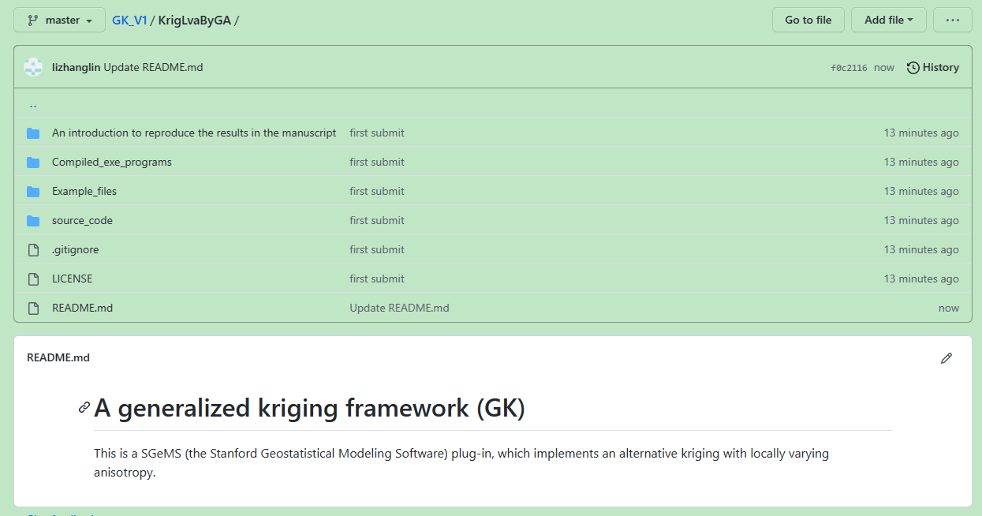

**Figure 1**

## Operation steps

There are four operation steps to perform the GK-based estimation or simulation.

1. Open the file “KrigLavByGA\Compiled_exe_programs\LibX64\Sgems_X64.exe” (**Figure 2**). Normally, the plug-in of GK will be loaded automatically and shown in estimation and simulation category of the algorithm panel (**Figure 3** and **Figure 4**).

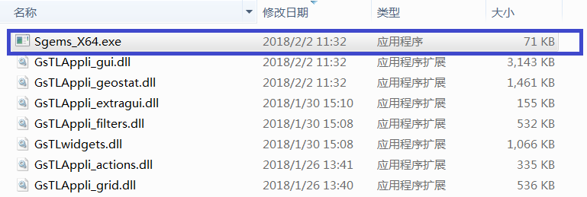

**Figure 2**

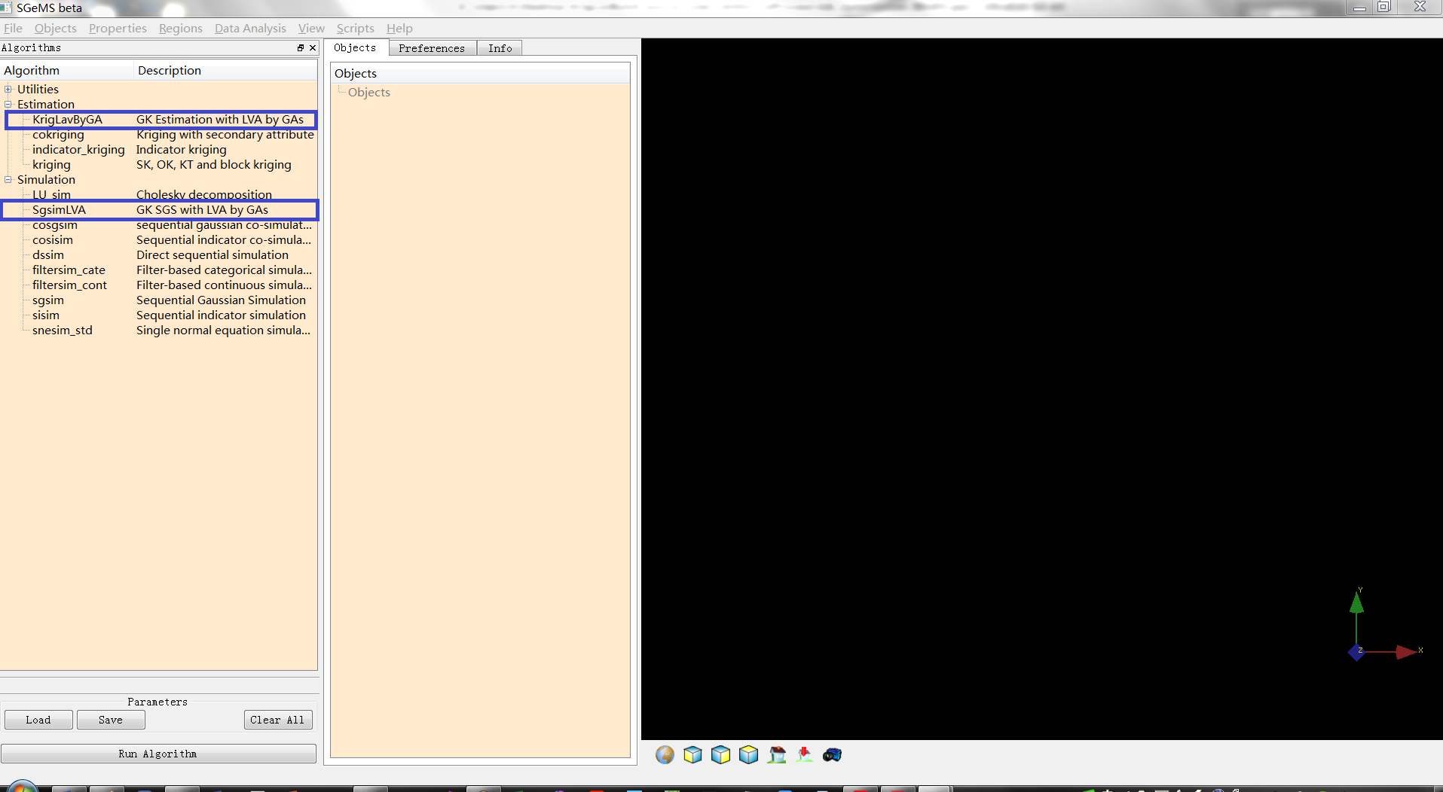

**Figure 3**

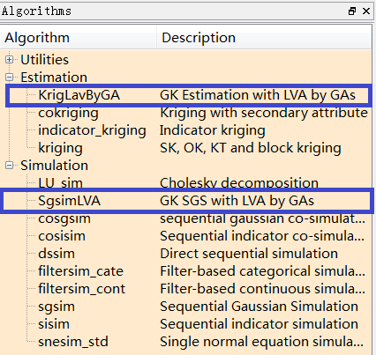

**Figure 4**

1. Use the menu “File | Open project” to open the test project files “KrigLavByGA\Example_files\dataset_1\ori_data\anticline.prj” (**Figure 5** and **Figure 6**).

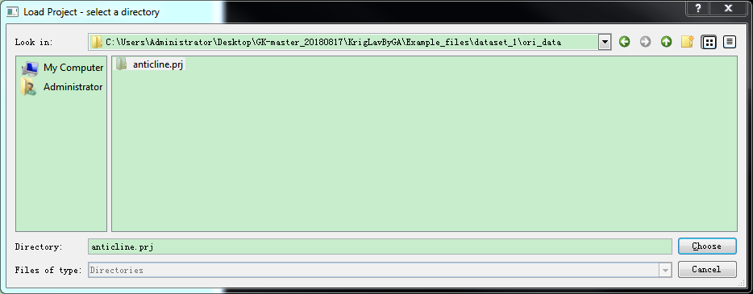

**Figure 5**

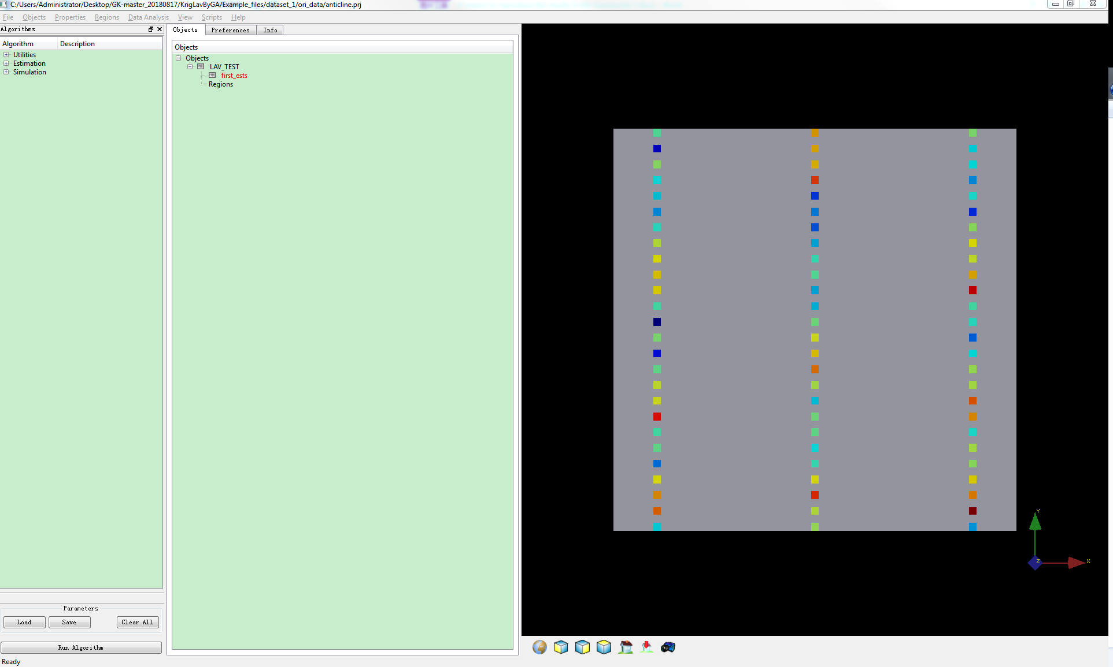

**Figure 6**

1. Click the “load” button (**Figure 6**) to open one of the test parameters corresponding to the estimation or simulation with the three variogram models (Table 1). The GK-estimation algorithm will be located automatically, and the common parameters in an estimation process, such as the variogram model, search neighborhood, estimation grid and property, hard data and property will also be set automatically. See **Figure 7**, **Figure 8**, **Figure 9** and **Figure 10**.

Table 1 The used parameter file (KrigLavByGA\Example_files\dataset_1\pars) in the paper

|  |  |  |
| --- | --- | --- |
| Modeling method | Variogram model | The parameter file |
| Estimation | The exponential model | DATA1_EST_Exp_65.par |
| The Gaussian model | DATA1_EST_Gau_45.par |
| The spherical model | DATA1_EST_Sph_55.par |
| Simulation | The exponential model | DATA1_SIM_Exp_65.par |
| The Gaussian model | DATA1_SIM_Gau_45.par |
| The spherical model | DATA1_SIM_Sph_55.par |

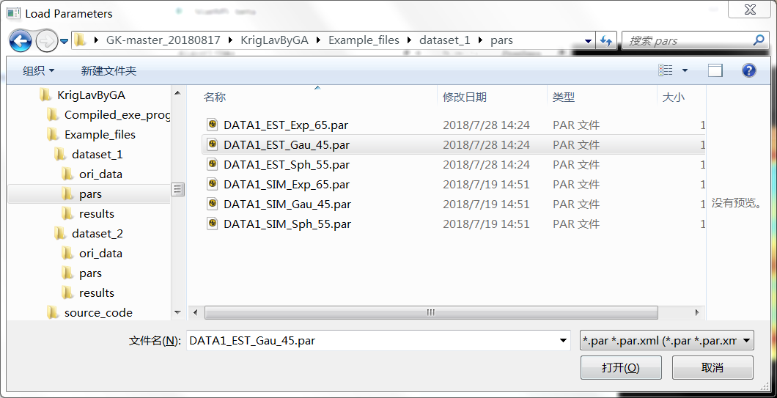

**Figure 7**

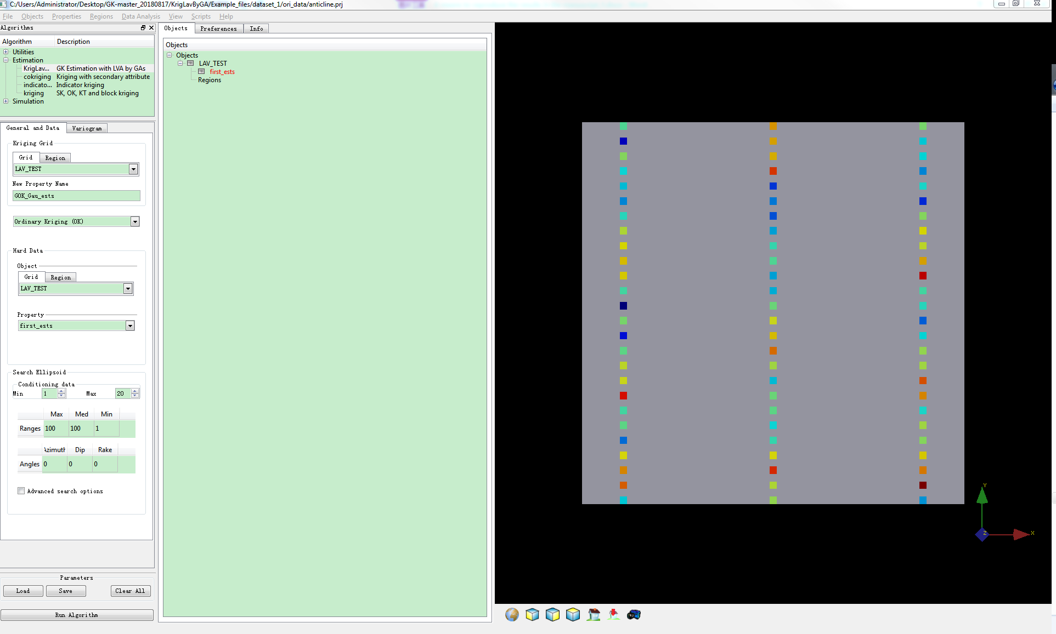

**Figure 8**

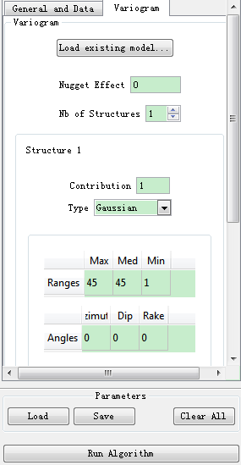

**Figure 9**

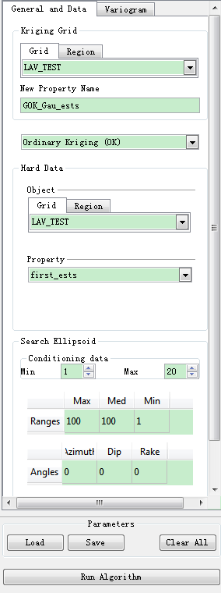

**Figure 10**

1. Click the “Run algorithm” button in **Figure 10** to perform the algorithm. The value of “The new property” is suggested to be changed to identify the different or method being applied. Following the above steps, the result in **Figure 11** will be produced. The menu “Object| Save Object” can be used to export the resulting data as a CSV or Gslib file for additional analysis.

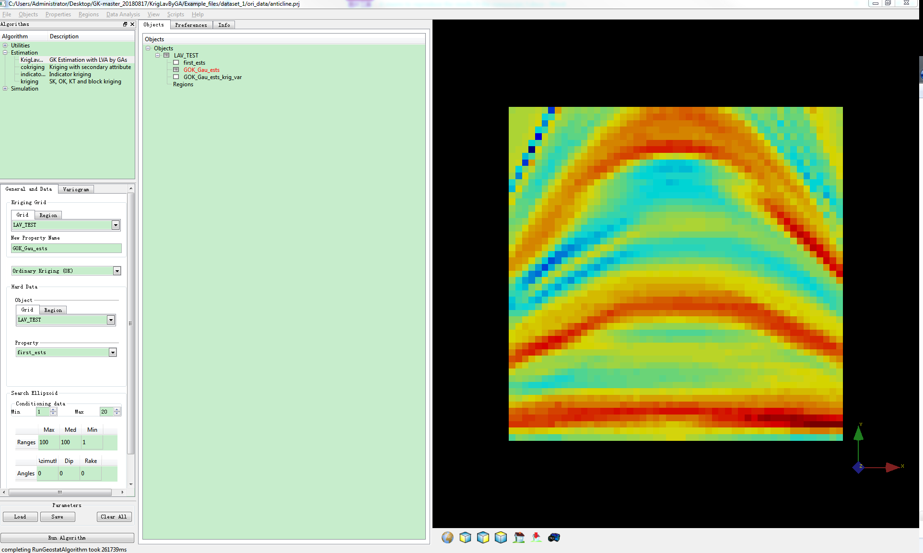

**Figure 11**

## Parameter configurations

1. **Figure 12** shows the GA parameters used in the paper. These parameters can be changed if necessary.

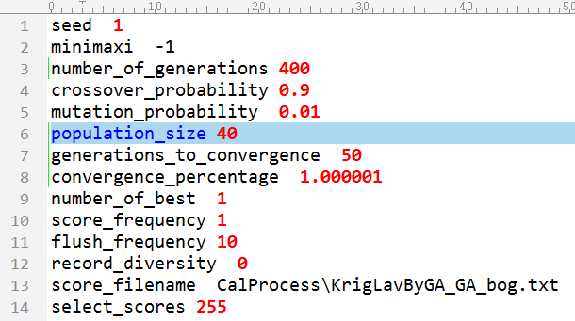

**Figure 12 Primary contents in the parameter file:**

“KrigLavByGA\Compiled_exe_programs\LibX64\CalProcess\GA_Optimization_MinKV.par”

1. **Figure 13** shows the detailed configuration of GK methods. Please note that the values of item ①~④ in this figure should be changed produce all of the different modeling methods applied in the paper. For example, the paramether shown in Table 2 can be used.

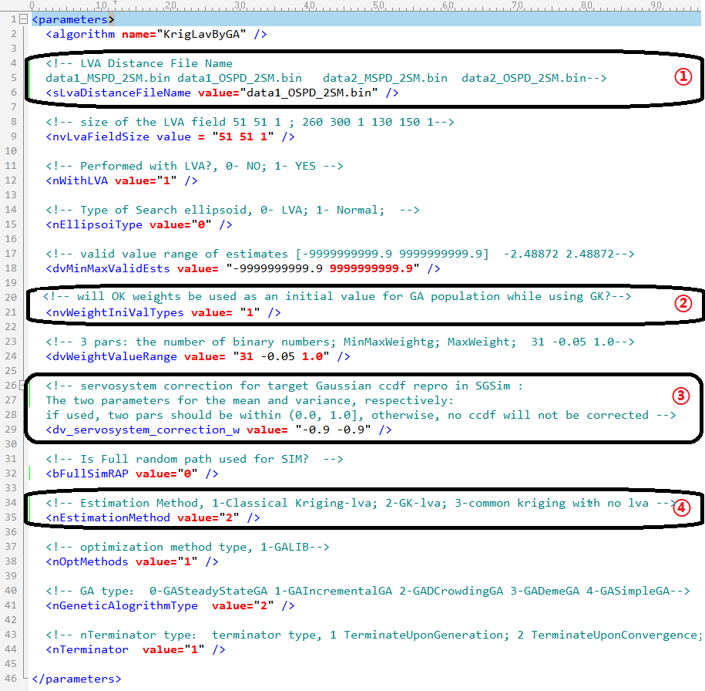

**Figure 13 Primary contents in the parameter file:**

“KrigLavByGA\Compiled_exe_programs\LibX64\CalProcess \ KrigLavByGA.par”

Table 2 Combination parameters to form the modeling method applied in the paper

|  |  |  |
| --- | --- | --- |
| Estimation method | Value of item ① | Value of item ④ |
| OSPD-GOK | data1_OSPD_2SM.bin | 2 |
| MSPD-GOK | data1_MSPD_2SM.bin | 2 |
| MSPD-TOK | data1_MSPD_2SM.bin | 1 |

## A video demonstration

A detailed demonstration that indicates how to use the GK in estimation and simulation is also prepared in [the accompanying video](GK_EstSim_Demo/GK_Estimation_Sims.mp4) with this document.

## Notes

Please note that all of the examples above are illustrated using *testdata_1*. The same operations can also be used to conduct the modeling based on *testdata_2*.